User Experience Design with VR
1. Introduction
1.1 Introduction to interface design, Understanding and conceptualizing Interface, understanding user’s conceptual cognition, Core Elements of User Experience, Working of UX elements
PAST QUESTIONS:
- Explain user interface design? (D23)
- What is cognition? Explain cognitive processes? (D23)
- Give differences between User experience and User Interface? (D23)
- Explain core elements of User Experience? (D23)
- Explain user’s conceptual cognition. (M24)
NOTES:

*User Interface Design :-
User interface (UI) design is the process of creating the visual and interactive elements of a digital product, such as a website or app, that a user directly engages with. It focuses on the look, feel, and interactivity of elements like buttons, menus, icons, and typography to create an interface that is both aesthetically pleasing and easy to use. The main goal is to make the interaction between a user and a product intuitive, clear, and efficient.
User Interface (UI) design focuses on the visual elements directly engaged by users.
The user interface is the front-end application view to which the user interacts to use the software. The software becomes more popular if its user interface is:
- Attractive
- Simple to use
- Responsive in a short time
- Clear to understand
- Consistent on all interface screens

*Cognition :-
Cognition refers to the study of mental processes like perception, memory, attention, and problem-solving, which are applied to understand how users think, process information, and make decisions when interacting with a product or interface.
Perception: How users interpret information, like visual layouts and relationships in a digital interface.
Memory: How users retain and recall information, guiding their expectations for a product.
Attention: How users focus their mental resources, which can be depleted by complex or poorly designed interfaces.
Problem-Solving: The cognitive processes involved when users try to achieve a goal using a digital product.

*Conceptual Cognition :-
When designing any system (website, app, software), it’s important to understand how users think, learn, and process information. This is called conceptual cognition in Human–Computer Interaction (HCI) and UX design.
Understanding users’ conceptual cognition means recognizing how they think, perceive, and remember while using a system, and designing interfaces that align with these mental processes.
It refers to the mental processes users apply while interacting with a system: attention, perception, memory, learning, problem-solving, and reasoning.

*Core elements of UX :-
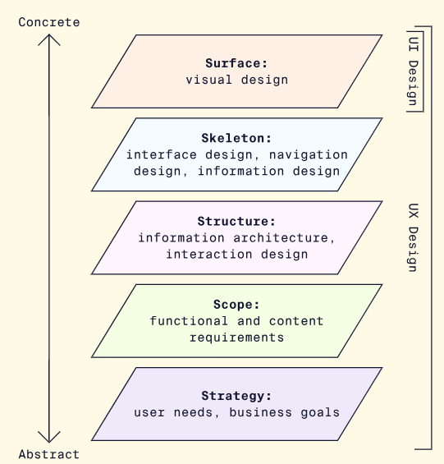
- Strategy - The first layer is strategy. In this phase, the designer gathers information and lays the foundation while keeping in view the needs of the users and business objectives. The designer researches who the users and the end-users are, as well as their needs, pain points, etc.
- Scope - The designer decides on the idea and type of content they are designing. They set their requirements and goals. The team defines functional requirements (what features to build) and content requirements (written and visual information to include).
- Structure - The third layer is structure. Here the designer decides the organization of the design, and how the system will behave when the user interacts with the product.
- Skeleton - This is the fourth layer. The designer puts together the previous pieces to determine the visual form of the design. Here, the designer decides the flow of information and movement from one screen to the next. The designer makes sure that navigation is smooth and the presentation of information facilitates user understanding.
- Surface - This is the final layer. The designer decides on the layout of the visuals, typography, styling, and colours. The designer finalizes the final ‘surface’ that the user is going to interact with to make it easy to use and navigate.

*UX vs UI :-
